Social Media Analytics via Graph Visualization

Rutvikkumar Ghori Computer Engineering Lakehead University Thunder Bay, Canada Email: [rghori@lakeheadu.ca](mailto:rghori@lakeheadu.ca)

Muhammad Iqbal Computer Engineering Lakehead University Thunder Bay, Canada

Email: [miqbal7@lakeheadu.ca](mailto:miqbal7@lakeheadu.ca)

Jay Chovatiya Computer Engineering Lakehead University Thunder Bay, Canada

Email: [jchovati@lakeheadu.ca](mailto:jchovati@lakeheadu.ca)

Siddhi Jariwala Computer Engineering Lakehead University Thunder Bay, Canada

Email: [sjariwa2@lakeheadu.ca](mailto:sjariwa2@lakeheadu.ca)

Dhruv Patel Computer Engineering Lakehead University Thunder Bay, Canada

Email: [dpate185@lakeheadu.ca](mailto:dpate185@lakeheadu.ca)

1. KEYWORDS

Sentiment analysis,Topic detection,Social Network Analysis,Collaborative Recommendation,Computational Intelligence,Online Social Networks,graph analysis

***Abstract*—The emergence of Online Social Networks (OSN) has been a catalyst for the Big Data era. The continuous flow of breaking news and trends in real-time triggers a surge of opinion- ated content that spreads rapidly across this vast, interconnected system, shaping public behaviors and knowledge construction. Analyzing this data requires the integration of scientific tools and expertise across various disciplines, including social network analysis, sentiment analysis, trend analysis, and collaborative recommendation. However, due to the recent emergence of these tools and the complexity of processing human-generated data, there is a need for a comprehensive and updated taxonomy of social data networking analysis frameworks. This paper aims to provide a sophisticated classification of current state-of-the- art frameworks, taking into account the diversity of practices, methods, and techniques. It is the first attempt to illustrate the entire spectrum of social data networking analysis and their associated frameworks. The survey highlights challenges and future directions, with a particular focus on text mining and the promising avenue of computational intelligence.** **[1]**

1. INTRODUCTION

The emergence of online social networks has had a profound impact on our daily lives by enabling us to communicate and collaborate with individuals across the world in real time. Furthermore, the large-scale data generated by these networks has given rise to new areas of study, such as computational social science, which seeks to analyze human behavior.In the business realm, social network analysis has become a valuable tool for understanding consumer behavior and market trends. By analyzing the relationships between individuals

and communities, businesses can identify influential individu- als, target specific demographics, and develop more effective marketing strategies. Similarly, in politics, social media has become an essential tool for political campaigns to reach a broader audience and engage with voters in real time. However, the use of social media in politics has also led to concerns about the spread of misinformation and fake news. The establishment of the MIT Center for Connection Science and Engineering demonstrates the growing importance of social network analysis in understanding complex social structures. Through analyzing connections between individuals and groups, researchers can gain insights into the functioning of financial markets, governments, and other large-scale social structures. The example of movie rental services illustrates how online social networks have transformed our consumption of media. By analyzing user data, these services can create personalized recommendations, providing a more tailored and enjoyable experience for users. To put it into another way, the rise of online social networks has had a significant impact on various aspects of our daily lives, from how we connect with others to how we consume media and engage in politics. As social network analysis continues to evolve, it is likely that we will see even more transformative changes in the future. [2] [3]

The term ”social media analytics” alludes to the practise of gathering information from social media platforms and using it to inform decision-making. Many different types of individuals have used social media analytics, including social scientists, business managers, and healthcare providers. Compared to conventional media analysis, where data collection is fre- quently manual and the analysis is labour-intensive, automated social media analytics is cheap and quick. When well-known

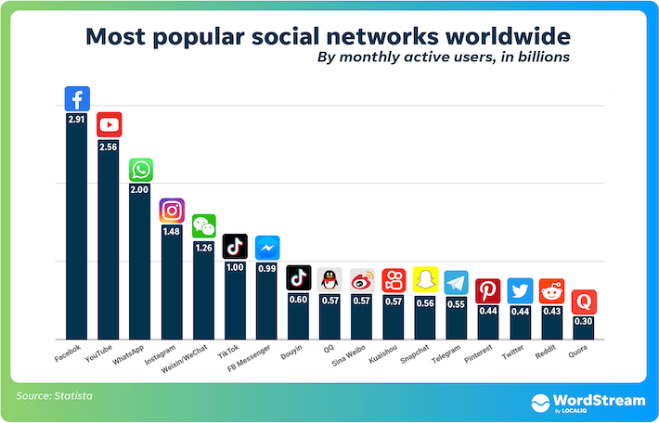Fig. 1: Graph of social networks

1. METHODOLOGY, (MATERIALS AND METHODS)

social media platforms made it possible for businesses to access vast quantities of customer data from their websites, the popularity of social media analytics skyrocketed. Social media networks place a strong emphasis on niche communities of content producers and consumers. A real-time information network like Twitter, for instance, links users and followers to the newest stories, concepts, views, [4]

Because they are used extensively across all websites and in the government, political, educational, financial, entertainment, and a broad range of other domains, social networks like Facebook, Twitter, Snapchat, and Instagram are very popular. Numerous government agencies make use of them to advertise any kind of deal or propaganda, including corona virus daily cases, vaccination dates, test results, etc. Social networks are very well-liked because they make it easy to meet new people, are great for finding jobs, and assist businesses in reaching out to prospective clients, as shown in Fig. 1.

According to social network theory, which aims to describe how networks function and examine the intricate web of connections within a network of people or organizations, social network analysis is the process of analysing the structures of social networks. (Scott, 2012; Wasserman Faust, 1994). Nodes in a social network are the individual players, and ties repre- sent the connections among the actors. By simulating social network dynamics and providing both visual and numerical analyses of actor connections within a network, social network analysis.

Although IS (information systems) researchers have shown that social media analytics can be helpful in several phases of a crisis, many EMAs (emergency management agencies) have not yet grasped the potential of using social media for crisis management. (Ahmed, 2011; Houston et al., 2015). Previous research has demonstrated that social media analytics can identify a problem before it is publicly reported. (Cameron et al., 2012; Crooks et al., 2013). EMAs could respond to crises more quickly and dispatch aid sooner if they used social media analytics. At least some EMAs are already using existing data gathering techniques and even social media analytics tools (Ludwig et al., 2015b). The American Red Cross, for instance, makes use of social media. [5]

1. *Dataset*

In this research paper, Netflix TV Shows and Movies (2022 Updated) are used. This dataset can be found on Kaggle. Here, whole dataset to see

[https://www.kaggle.com/datasets/thedevastator/](https://www.kaggle.com/datasets/thedevastator/the-ultimate-netflix-tv-shows-and-movies-dataset) [the-ultimate-netflix-tv-shows-and-movies-dataset](https://www.kaggle.com/datasets/thedevastator/the-ultimate-netflix-tv-shows-and-movies-dataset)

This dataset includes multiple csv file of Netfix movies and shows. Among them, some are of best shows and best movies. In this research paper, Netflix best movie and Netflix best shows are used to show graphs. Both file has 7 features including release year, main production and title. In this paper, we have shown graph that shows relationship among them.

1. *Methodology*
   1. Network Components [6] We’ll start with a brief intro in network’s basic components: nodes and edges. Nodes (A,B,C,D,E ) are normally representing entities in the net- work, and can hold self-properties (such as weight, size, position) and network-based properties (such as Degree- number of neighbours or density or Cluster- a connected component the node belongs to etc.). Edges represent the relationship between the nodes, and may keep properties as well (such as weight representing the strength of the connection, direction in case of asymmetric relation).

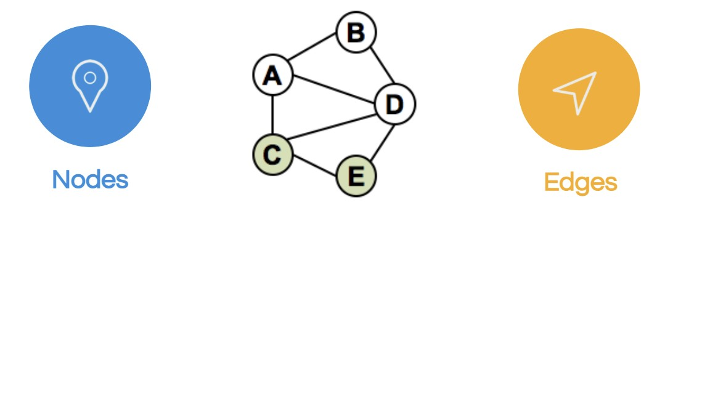

**Degree centrality**: The first and simplest measure is the degree centrality. Degree centrality is formerly the most common and theoretically the simplest, defined as the quantity of links incident upon a given node (i.e., the number of ties that a node has), and can be interpreted in terms of the immediate risk of a node for catching whatever is flowing through the network (such as a virus, or some information). In the case of a directed network (where ties have direction), we typically define two separate measures of degree centrality, namely indegree and outdegree. As a result, indegree is a total of the ties that are directed to the node, and outdegree is a count of the ties that the node sends to other nodes. Outdegree is frequently seen as friendly nature and indegree as a form of popularity when connections are connected to positive aspects like friendship or cooperation. [7]

**Closeness centrality**: The mean length of the shortest route connecting a node to every other node in the net- work is the normalised closeness centrality (or closeness) of that node. As a result, a node is closest to all other nodes the more central it is.

According to Bavelas (1950), proximity is the opposite

data from the excel file will be read into a pandas dataframe. We’ll melt the dataset to be sure that each row reflects just one vote (edge) between two countries since each row represents all of a country’s votes. (nodes). After that, we will use networkx to construct a directed graph from the edgelist we have available as a pandas dataframe. We’ll attempt the

of distance, so:

*CB*(*x*) =

*y*

Σ

1

*,*

*d*(*y, x*)

general visualisation technique last, as shown in code 1 (the complete code is available).

People typically refer to closeness centrality in its normalised version, which shows the average length of the closest paths rather than their sum. The formula above is multiplied by N-1, where N is the number of nodes in the graph, and the outcome is as follows:

*N −* 1

Σ

[https://github.com/technicalrutvik/Social Network Analysis](https://github.com/technicalrutvik/Social_Network_Analysis) i m p o r t networkx as nx

i m p o r t m a t p l o t l i b . p y p l o t as p l t g = nx . Graph ( )

g1=nx . Graph ( )

*C*(*x*) =

*y*

*.*

*d*(*y, x*)

g=nx . f r o m p a n d a s e d g e l i s t ( ds , s o u r c e =” TITLE ” , t a r g e t =”RELEASE YEAR” )

**Betweenness centrality**: Betweenness centrality,

which depends on shortest paths, is a measure of centrality in a network in graph theory. In a connected graph, there is at least one shortest route between each pair of vertices that minimizes the sum of the weights of the edges (for weighted graphs) or the number of edges the path goes through (for unweighted graphs). The number of these shortest paths that travel through a vertex determines its betweenness centrality.

A graph’s vertex’s interconnection serves as a measure of its centrality. The amount of times a node serves as a bridge over the shortest distance between two other nodes is measured by betweenness centrality. Linton Freeman developed it as a way to gauge how much an individual can influence how people communicate with one another online. According to his theory, vertices with a high betweenness are those whose occurrence on the shortest route between two randomly chosen vertices has a high probability.

The expression: gives the betweenness centre of node v

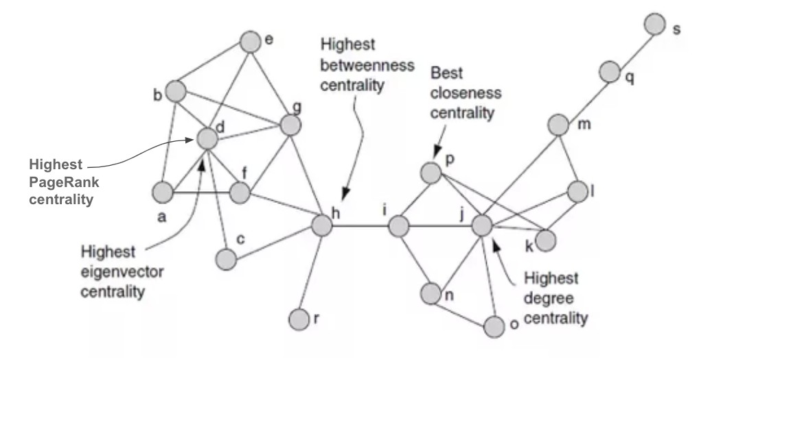

[8]. *g*(*v*) = Σ

*s̸*=*v*=*̸ t*

*σst*(*v*)

*σst*

1. *Building Network*

Any dataset can be used to build a network as long as the connections between the components can be described. Using the Python networkx [9] package, we will construct and visualise the Eurovision 2018 votes network (based on official data2). To obtain a tabular depiction of the votes, the

p l t . f i g u r e ( f i g s i z e =( 80 , 8 0 ) )

pos=nx . s p r i n g l a y o u t ( g , k = 0 . 5 )

nx . draw networkx ( g , pos ,

n o d e s i z e = node s i zes movie ,

n o d e c o l o r =color map movie , f o n t s i z e = 25 , f o n t w e i g h t = ’ bold ’ , f o n t c o l o r = ’ black ’ )

p l t . show ( )

1. RESULTS

According the Python code that we created and visualises a graph from a Pandas DataFrame called ds, which has two columns designated release year and main genre .Intially, the DataFrame is graphed using the from pandas edgelist function, with the release year column as the source node and the main genre column as the target node. This means that each row in the dataFrame indicates a graph edge, with the release year value indicating where the edge begins and the main genre value indicating where the edge ends.The number of nodes and number of edges functions are then used to print the number of nodes and edges in the graph.Finally, the spring layout and draw networkx functions are used to position the nodes in the graph and draw the graph with node labels. The plt.show() function is used to illustrate the resulting graph.It is worth noting that the k parameter in spring layout defines the distance between nodes. A smaller k value results in a more compact graph, while a bigger k value results in a more spread-out graph.To capit all,it can be visible from the graph that it has 64 nodes and 165 edges. [10] [3]

The graph has 42 nodes and 98 edges which is similar to the prior code, but instead of using the dataframe ds, it creates and visualises the graph using a different dataframe called ds2.The graph is generated from the dataframe using the from pandas edgelist function, with the RELEASE YEAR column serving as the parent node and the MAIN GENRE column serving as the target node.The number of nodes and number of edges functions are then used to print the number of nodes and edges

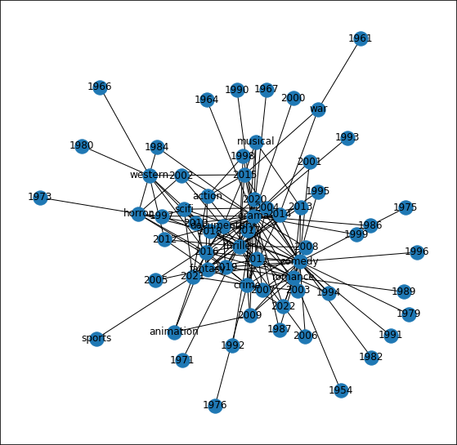

Fig. 2: The graph has 64 nodes and 165 edges

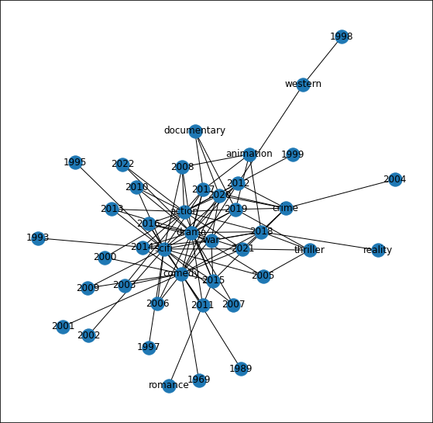

Fig. 3: The graph has 42 nodes and 98 edges

in the graph.Finally, the spring layout and draw networkx [11] functions are used to position the nodes in the graph and draw the graph with node labels. The pltshow() function is used to illustrate the resulting graph.It is essential to note that the ds2 dataframe’s meaning and structure may differ from the use of ds dataframe in the preceding code, the resulting graph may vary. [1]

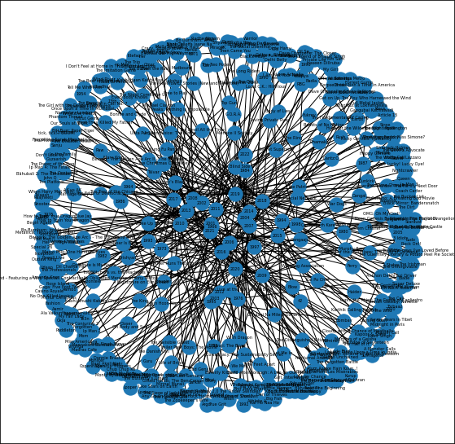

Fig. 4: Number of nodes: 436 Number of edges: 387 Density: 0.004080987029421069 Is directed: False

In this section we have created a list called color map movie that will be used to specify the color of each node in the network graph created earlier. The node sizes movie list is

also being created to specify the size of each node in the graph.Then the code iterates over each node in the graph g and checks if it is present in the ”RELEASE YEAR” column of the ds Dataframe. If the node is present in this column, it is assigned a blue color and a larger size of 3000. If the node is not present in the column, it is assigned a red color and a smaller size of 1500.The code also creates two dictionaries, dict size and dict, but they are not used in this code snippet. They may be used elsewhere in the program.

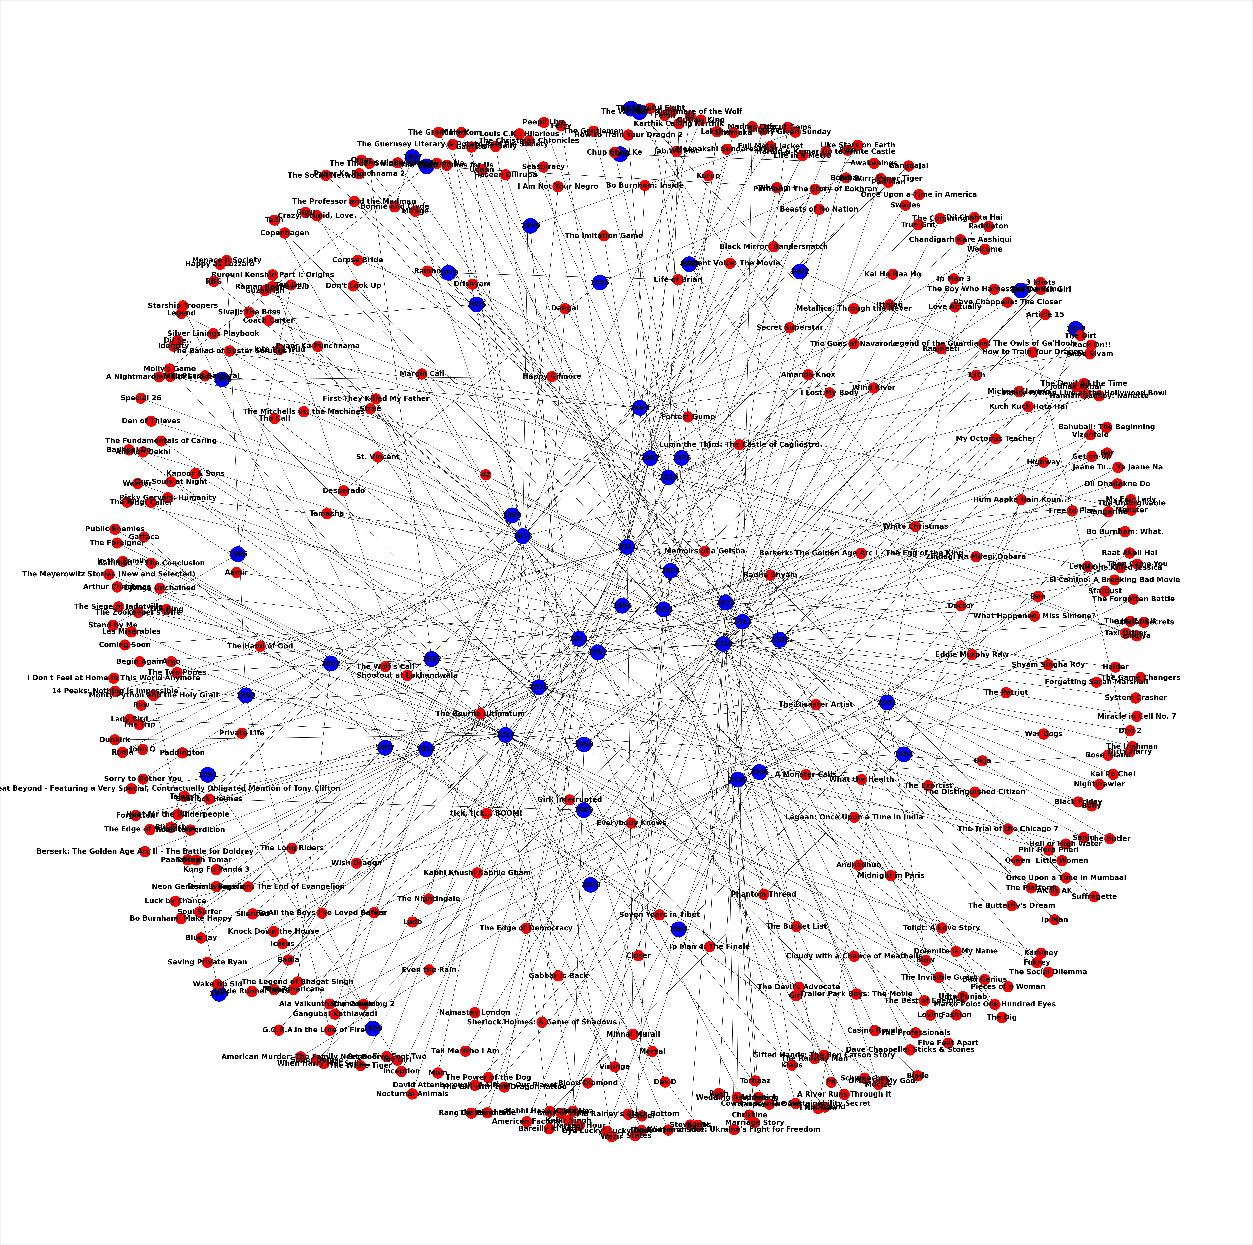

Fig. 5: Number of nodes: 436 Number of edges: 387 Graph density: 0.00

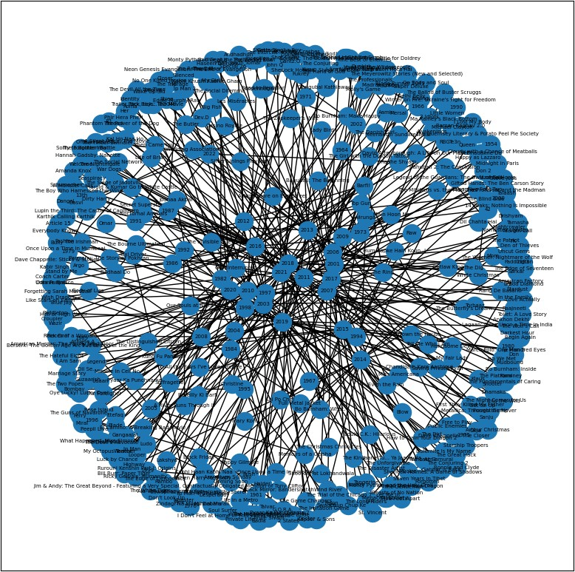

Fig. 6: Number of nodes: 436, Number of edges: 387 , Density: 0.004080987029421069 , Is directed: False

1. DISCUSSION AND ARGUMENTS

The primary point of ”Social Media Analytics via Graph Visualization” is that graph visualisation can be a useful tool for analysing social media data. Patterns and relationships between users and their interactions can be readily identified and analysed by visualising social media data in a graph format. This can contribute to valuable insights into user

behavior, sentiment, and community structures for businesses, researchers, and policymakers equally.Furthermore, graph vi- sualisation can enable users to interactively explore social me- dia data by dynamically filtering and manipulating the graph to obtain deeper insights. This can assist users in identifying trends and anomalies in data that traditional data analysis techniques may miss. However, there are some drawbacks to using graph visualisation for social media analytics, such as the requirement for effective data cleaning and preprocessing, managing large datasets, and correctly interpreting the visu- alisations. Future research could concentrate on developing more advanced graph visualisation techniques, improving data preprocessing methods, and investigating the use of machine learning and artificial intelligence to assist in the analysis of social media data via graph visualisation. Another reason to use graph visualisation for social media analytics is that it can reveal hidden patterns and insights that are not instantly apparent from raw data. Researchers can spot clusters and sub-communities with distinct behaviours or characteristics by visualising the connections between individuals and commu- nities. These insights can be used to guide targeted marketing strategies, identify potential influencers, and even detect and prevent fraudulent or malicious behaviour. Overall, graph visu- alisation is a powerful instrument for unlocking the potential of social media data and understanding complex social networks.

* Social media analytics via graph visualization has its critics who argue that it is not a reliable way to make informed decisions. According to these critics, graph visualization oversimplifies complex data, which leads to inaccurate conclusions. Moreover, they argue that graph visualization cannot capture the subtleties of human behavior, making it ineffective in predicting future trends.
* There is some evidence to support the idea that graph visualization can be misleading. A study conducted by researchers at the University of Texas at Austin found that graph visualization can lead to biased conclusions, especially when the graph is too complex. The study also revealed that graph visualization can obscure important data points, leading to inaccurate interpretations. This means that relying solely on graph visualization can result in oversimplification, leading to an incorrect understand- ing of the data.

Moreover, critics argue that social media analytics via graph visualization cannot account for the nuances of human behavior. A study published in the journal Infor- mation Systems Research found that social media data is often incomplete and unreliable, making it difficult to draw meaningful conclusions. Additionally, critics ar- gue that graph visualization cannot capture the complex relationships between individuals and groups, making it ineffective in predicting future trends. This means that social media data may not be representative of actual human behavior, leading to inaccurate predictions.

* While it is true that graph visualization can be misleading when used improperly, this does not mean that it is

inherently flawed. In fact, many experts believe that graph visualization can be a powerful tool for understanding complex data. By using visualization software, analysts can identify patterns and relationships that might other- wise go unnoticed, leading to more accurate and informed decision-making.

Moreover, while it is true that social media data can be incomplete and unreliable, this does not mean that it is useless. By using advanced algorithms and machine learning techniques, analysts can filter out irrelevant data and identify meaningful patterns in the data. For example, sentiment analysis can be used to determine the overall mood of a social media conversation. Additionally, social media analytics via graph visualization can be combined with other sources of data, such as surveys and focus groups, to provide a more complete picture of consumer behavior.

Furthermore, the critics’ argument that graph visualiza- tion cannot capture the complex relationships between individuals and groups is not entirely true. While graph visualization may not capture every aspect of social behavior, it can still provide valuable insights into social networks and communities. Moreover, advanced tech- niques, such as social network analysis, can be used to an- alyze the complex relationships between individuals and groups, leading to a more comprehensive understanding of social behavior.

* There is ample evidence to support the argument that social media analytics via graph visualization can be an effective tool for understanding consumer behavior. For example, a study published in the Journal of Business Research found that social media analytics can be used to predict consumer behavior with a high degree of accuracy. The study also revealed that graph visualization can be used to identify key influencers and communities within social networks, allowing marketers to tailor their messages to specific audiences. This shows that graph visualization can help identify influential individuals and groups that drive consumer behavior.

Furthermore, a study published in the Journal of Infor- mation Technology found that graph visualization can be used to identify patterns in social media data that are not apparent through other means. The study also revealed that graph visualization can be used to identify emergent trends in real-time, allowing analysts to respond quickly to changes in the marketplace. This shows that graph visualization can provide valuable insights into consumer behavior that can be used to inform marketing strategies and product development.

In conclusion, while there are some legitimate concerns about social media analytics via graph visualization, the evidence suggests that it can be a powerful tool for un- derstanding consumer behavior. By combining advanced algorithms and machine learning techniques with

1. EDUCATED OPINIONS

According to our opinion,massive amounts of data are generated by social media platforms, making it challenging for companies and people to comprehend and interpret the information. Graph visualisation methods improve data comprehension by displaying interactive and dynamic representations of user connections, activities, and interests. This can assist companies and people in making more informed marketing, content production, and engagement strategies.New features and algorithms on social media platforms are continuously changing the way users engage with one another and with the platform. By giving a visual representation of the network and its dynamics, graph visualisation methods can assist companies and people in keeping up with these changes. This can assist companies and people in adapting their strategies and remaining competitive. On the other hand,Graph visualisation methods for social media metrics may not be appropriate for all data kinds. Some data may not lend themselves well to representation, or the visualisation may be too complicated for consumers to comprehend. Alternative methods, such as statistical analysis or machine learning, may be more suitable in these situations.Graph visualisation methods for social media metrics can be time-consuming and technical in nature. Smaller businesses or individuals without access to specialised tools may find it difficult to use these methods successfully. Furthermore, the precision of the analysis may be influenced by the data quality and the limitations of the visualisation tools. Another compelling reason to use graph visualisation methods in social media analytics is the ability to identify important people and communities within a network. Graph visualisation can show patterns of impact and help identify important actors in a social network by analysing user links and interactions. This data can help companies and organisations target particular demographics or influencers in their marketing strategies.On the contrary,one possible poor case for using graph visualisation in social media analytics is that it is constrained by the quality and accuracy of the available data. The quantity and type of data that can be viewed and analysed on social media platforms is frequently limited, which can limit the efficacy of graph visualisation methods. Furthermore, social media users may not always correctly portray themselves or their connections, resulting in inaccuracies in the visualised network. These limitations, however, are frequently mitigated by meticulous data cleaning and analytic methods.

* + A. Social media analytics through graph visualization is an effective method for understanding and analyzing user behavior.

**Opinion**: Graph visualization provides a comprehensive and clear view of user behavior on social media plat- forms.

# Support:

1. According to a study by IBM, graph visualization

can provide insights into user behavior that tra- ditional analytics methods cannot. It can help in identifying patterns, trends, and anomalies that can be missed by other methods. [12]

1. A report by Gartner states that graph analytics can help in identifying fraud, detecting network intrusions, and providing insight into customer be- havior. [13]
2. A case study by Amazon Web Services shows how graph visualization helped in analyzing user behavior on their e-commerce platform, resulting in improved recommendations and increased customer engagement. objectives [14].

* Graph visualization can be used to detect and prevent social media abuse and harassment.

**Opinion**: Graph visualization can help in identifying and tracking abusive behavior on social media platforms, thereby enabling timely intervention and prevention. [15] **Support**:

1. A study by the University of Cambridge found that graph analysis could help in detecting abusive behavior on social media platforms. The study used graph visualization to analyze the connections be- tween users, identifying patterns of abusive behav- ior. [16]
2. Facebook uses graph analysis to detect and prevent fake accounts and spam. The company also uses graph visualization to identify patterns of abusive behavior, such as hate speech and harassment. [17]
3. The Anti-Defamation League (ADL) uses graph analysis to track and monitor hate speech and ex- tremist behavior on social media platforms. [18]

* Graph visualization can help in improving the effective- ness of social media marketing.

**Opinion**: Graph visualization can provide insights into user behavior that can be used to improve social media marketing strategies.

# Support:

1. A study by McKinsey found that companies that use analytics and data visualization in their marketing strategies are more likely to achieve their marketing objectives [19].
2. Graph visualization can help in identifying user behavior patterns that can be used to improve the relevance and targeting of social media advertising.
3. A case study by Twitter shows how graph visu- alization helped in identifying and targeting key influencers on the platform, resulting in improved engagement and increased reach. [20]

In conclusion, social media analytics through graph visualization is an effective method for understanding and analyzing user behavior, detecting and preventing social media abuse and harassment, and improving the effectiveness of social media marketing. The use of graph visualization can provide valuable insights into user

behavior that can be used to inform decision-making and improve outcomes.

1. FUTURE WORK

In the forthcoming time ,we are planning to improve senti- ment analysis accuracy by using machine learning algorithms such as deep learning to train models on big datasets is one way to improve sentiment analysis accuracy. You can increase the precision and recall of your sentiment analysis model by doing so.Investigate novel visualisation techniques: While graph visualisation is a powerful method for visualising social media data, you can also experiment with other visualisation techniques. Heat maps and network graphs, for example, can be used to emphasise patterns and trends in social media data.Utilize user behaviour analysis: you can analyse user behaviour such as liking, commenting, and sharing in addition to the substance of social media posts. This allows you to obtain insights into user engagement and apply this knowledge to your social media marketing plan.Construct a real-time surveillance system: Social media is a fluid medium, and patterns can shift quickly. To keep up with the latest trends, create a real-time monitoring system that monitors social media activity and updates your analysis as needed.Analyze the efficacy of your analytic. Finally, you can assess the efficacy of your social media data by running experiments or A/B tests. we can then optimise your strategy based on the impact of your analytic on user engagement and other important metrics.

1. CONCLUSION

In conclusion, social media analytics via graph visualization is a valuable AI/ML technology that can provide valuable insights for businesses and individuals. By analyzing the relationships and connections between users and their activity on social media platforms, this technology can help identify trends, sentiment, and influencers in a particular market or community. Graph visualization allows for a more intuitive and interactive representation of data, enabling users to explore and identify patterns and insights more easily. This technology is particularly useful for businesses looking to optimize their marketing strategies, as it can help identify key influencers and target demographics. When considering whether to use social media analytics via graph visualization, it is important to first assess the specific needs and goals of your business or organization. This will help determine which social media platforms to analyze and what data to collect.

Once the data is collected, it is important to choose the right graph visualization tool that best suits your needs. There are a number of tools available, ranging from free and open- source options to more advanced and proprietary software. When selecting a tool, it is important to consider factors such as ease of use, flexibility, and scalability. It is also important to ensure that the tool is capable of handling the size and complexity of the data set you are working with.

Finally, it is important to have a clear plan for how to ana- lyze and interpret the data collected through graph visualiza-

tion. This may involve identifying key trends and influencers, developing targeted marketing strategies, or identifying areas for improvement in your social media presence. Overall, social media analytics via graph visualization is a powerful AI/ML technology that can provide valuable insights for businesses and individuals. By carefully selecting the right tools and developing a clear plan for analysis, this technology can help drive growth and success in the digital marketplace.

1. WORK CONTRIBUTION

All the members were involved in making the project progress.After a review of the Relevant work by each member, the final material was chosen.

1. *Siddhi jariwala and Rutvikkumar Ghori:*
   * Examine the numerous stages in social media analytic using graph visualization and different data sets and libraries. pre-processed the data in order to prepare it for the endeavor.

* Performed a literature study and gathered evidence.Applied fresh data-cleansing techniques that were helpful for our endeavor.

1. *Jay Chovatiya*
   * Establish which feature extraction techniques, parameter settings, and categorization methods produce the best out- comes.

* Developed a clean, understandable program with a proper system flow that produces the best results.

1. *Rutvik*
   * Using the code jay provided, the apply all the function which are suitable for the graph and ran a number of tests to assess the performance of each method.
2. *Muhammad Iqbal, Dhruv Patel*

* Researched on paper and give insights and help to other team-members.

REFERENCES

1. M. Thelwall, “Social media analytics for youtube comments: potential and limitations,” *International Journal of Social Research Methodology*, vol. 21, no. 3, pp. 303–316, 2018. [Online]. Available: <https://doi.org/10.1080/13645579.2017.1381821>
2. S. W. S. C´ecile Zachlod . Olga Samuel a, Andrea Ochsner, “Analytics of social media data – state of characteristics and application,” [https://www.sciencedirect.com/science/article/pii/S0148296322001321?](https://www.sciencedirect.com/science/article/pii/S0148296322001321?via%3Dihub) [via%3Dihub.](https://www.sciencedirect.com/science/article/pii/S0148296322001321?via%3Dihub)
3. U. Brandes and D. Wagner, *Analysis and Visualization of Social Net- works*. Berlin, Heidelberg: Springer Berlin Heidelberg, 2004, pp. 321– 340. [Online]. Available: [https://doi.org/10.1007/978-3-642-18638-7 15](https://doi.org/10.1007/978-3-642-18638-7_15)
4. I. Lee, “Social media analytics for enterprises: Typology, methods, and processes,” *Business Horizons*, vol. 61, 11 2017.
5. S. Stieglitz, M. Mirbabaie, J. Fromm, and S. Melzer, “The adoption of social media analytics for crisis management - challenges and opportunities,” 06 2018.
6. D. Goldenberg, “Social Network Analysis: From Graph Theory to Applications with Python,” *arXiv e-prints*, p. arXiv:2102.10014, Feb. 2021.
7. D. Combe, C. Largeron, E. Egyed-Zsigmond, and M. Ge´ry, “A com- parative study of social network analysis tools,” *WEB INTELLIGENCE VIRTUAL ENTERPRISES*, vol. 2, 10 2010.
8. A. Abraham, A.-E. Hassanien, and V. Sn’asˇel, *Computational Social Network Analysis: Trends, Tools and Research Advances*, 1st ed., ser. Computer Communications and Networks. Springer London, 2010. [Online]. Available: <https://doi.org/10.1007/978-1-84882-229-0>
9. A. Chaudhary, N. Jain, and A. Kumar, “Tools for social network analysis and mining,” in *2022 11th International Conference on System Modeling* *Advancement in Research Trends (SMART)*, 2022, pp. 1063–1067.
10. “Networkx,” [https://networkx.org/.](https://networkx.org/)
11. M. A. Motaleb Faysal and S. Arifuzzaman, “A comparative analysis of large-scale network visualization tools,” in *2018 IEEE International* *Conference on Big Data (Big Data)*, 2018, pp. 4837–4843.
12. IBM, [https://www.ibm.com/topics/exploratory-data-analysis.](https://www.ibm.com/topics/exploratory-data-analysis)
13. P. d. H. A. J. R. S. Jim Hare, Mark Beyer, [https://www.gartner.com/en/](https://www.gartner.com/en/documents/4013850) [documents/4013850.](https://www.gartner.com/en/documents/4013850)
14. J. P. Lareina Yee, “Marketing sales big data, analytics, and the future of marketing sales,” [https://www.mckinsey.com/∼/media/McKinsey/](https://www.mckinsey.com/~/media/McKinsey/Business%20Functions/Marketing%20and%20Sales/Our%20Insights/EBook%20Big%20data%20analytics%20and%20the%20future%20of%20marketing%20sales/Big-Data-eBook.ashx) [Business%20Functions/Marketing%20and%20Sales/Our%20Insights/](https://www.mckinsey.com/~/media/McKinsey/Business%20Functions/Marketing%20and%20Sales/Our%20Insights/EBook%20Big%20data%20analytics%20and%20the%20future%20of%20marketing%20sales/Big-Data-eBook.ashx) [EBook%20Big%20data%20analytics%20and%20the%20future%20of%](https://www.mckinsey.com/~/media/McKinsey/Business%20Functions/Marketing%20and%20Sales/Our%20Insights/EBook%20Big%20data%20analytics%20and%20the%20future%20of%20marketing%20sales/Big-Data-eBook.ashx) [20marketing%20sales/Big-Data-eBook.ashx.](https://www.mckinsey.com/~/media/McKinsey/Business%20Functions/Marketing%20and%20Sales/Our%20Insights/EBook%20Big%20data%20analytics%20and%20the%20future%20of%20marketing%20sales/Big-Data-eBook.ashx)
15. “How to improve your social media campaign us- ing data visualization,” [https://devrix.com/tutorial/](https://devrix.com/tutorial/improve-social-media-campaign-using-data-visualization/) [improve-social-media-campaign-using-data-visualization/.](https://devrix.com/tutorial/improve-social-media-campaign-using-data-visualization/)
16. B. Alzeer, “Multifaceted nlp analysis of hate speech and kinetic action descriptions,” [https://theses.lib.sfu.ca/file/thesis/5682.](https://theses.lib.sfu.ca/file/thesis/5682)
17. M. Jiang, P. Cui, and C. Faloutsos, “Suspicious behavior detection: Current trends and future directions,” *IEEE Intelligent Systems*, vol. 31, pp. 31–39, 01 2016.
18. T. A. L. F. I. for Combatting Antisemitism, “Audit of antisemitic incidents 2022,” [https://www.adl.org/resources/report/](https://www.adl.org/resources/report/audit-antisemitic-incidents-2022) [audit-antisemitic-incidents-2022.](https://www.adl.org/resources/report/audit-antisemitic-incidents-2022)
19. R. Bhandari, “Using marketing analytics to drive superior growth,” [https://www.mckinsey.com/capabilities/growth-marketing-and-sales/](https://www.mckinsey.com/capabilities/growth-marketing-and-sales/our-insights/using-marketing-analytics-to-drive-superior-growth) [our-insights/using-marketing-analytics-to-drive-superior-growth.](https://www.mckinsey.com/capabilities/growth-marketing-and-sales/our-insights/using-marketing-analytics-to-drive-superior-growth)
20. “The value of influencers on twitter,” [https://blog.twitter.com/en us/a/](https://blog.twitter.com/en_us/a/2016/new-research-the-value-of-influencers-on-twitter/) [2016/new-research-the-value-of-influencers-on-twitter/.](https://blog.twitter.com/en_us/a/2016/new-research-the-value-of-influencers-on-twitter/)